T1202
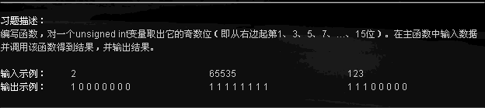
#include<stdio.h>
int main()
{ unsigned int i,j,n,k;
scanf("%u",&i);
i=i>>1;
k=i;
j=k&1u;
printf("%u",j);
for(n=1;n<=7;n++)
i=i>>2,k=i,j=k&1u,printf(" %u",j);
printf("\n");
return 0;
}

T1205
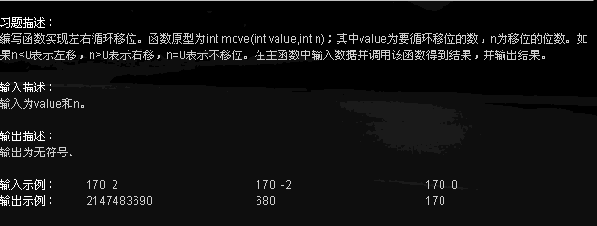
#include<stdio.h>
int main()
{
int n;
unsigned value;
int move(unsigned,int);
scanf("%u%d",&value,&n);
value=move(value,n);
printf("%u\n",value);
return 0;
}
unsigned move(unsigned value,int n)
{
unsigned t;
if(n==0) return value;
if(n>0){
t=~(~0<<n);
t=t&value;
t=t<<(32-n);
value=value>>n;
value=value|t;
}
else{
n=-n;
t=~(~0>>n);
t=t&value;
t=t>>(32-n);
value=value<<n;
value=value|t;
}
return value;
}
T1301
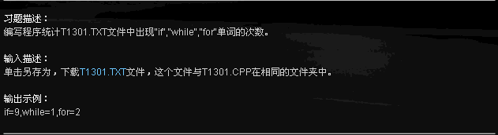
#include<stdio.h>
#include<stdlib.h>
int main()
{
int i=0,j=0,k=0;
FILE *p;
char ch;
p=fopen("T1301.TXT","r");
if(p==NULL){
exit(0);
}
while(!feof(p)){
ch=fgetc(p);
if(ch=='i'){
ch=fgetc(p);
if(ch=='f'){
i++;
}
}
if(ch=='w'){
ch=fgetc(p);
if(ch=='h'){
ch=fgetc(p);
if(ch=='i'){
ch=fgetc(p);
if(ch=='l'){
ch=fgetc(p);
if(ch=='e'){
j++;
}
}
}
}
}
if(ch=='f'){
ch=fgetc(p);
if(ch=='o'){
ch=fgetc(p);
if(ch=='r'){
k++;
}
}
}
}
fclose(p);
printf("if=%d,while=%d,for=%d\n",i,j,k);
return 0;
}

T1304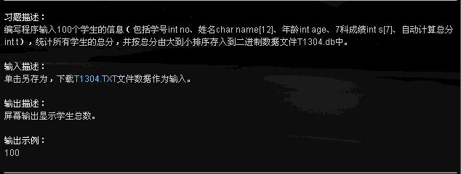

#include<stdio.h>
#include<stdlib.h>
int main()
{
struct stu{
int no;
char name[12];
int age;
int s[7];
int t;
}a[100],b;
FILE *p2;
int i,j,k,n=0,i1;
p2=fopen("T1304.db","wb");
//从文件中读取数据到a[100]
for(i=0;i<100;i++){
n++;
for(i1=0;i1<=12;i1++){
a[i].name[i1]='\0';
}
scanf("%d%s%d",&a[i].no,a[i].name,&a[i].age);
a[i].t=0;
for(j=0;j<7;j++){
scanf("%d",&a[i].s[j]);
a[i].t=a[i].s[j]+a[i].t;
}
}
//对a[100]进行排序
for(i=0;i<99;i++){
k=i;
for(j=i+1;j<100;j++){
if(a[k].t<a[j].t){
k=j;
}
}
if(k!=i){
b=a[i];
a[i]=a[k];
a[k]=b;
}
}
//将a[100]输入到文件中
for(i=0;i<100;i++){
fwrite(&a[i],sizeof(struct stu),1,p2);
}
printf("%d\n",n);
fclose(p2);
return 0;

}

SXL02
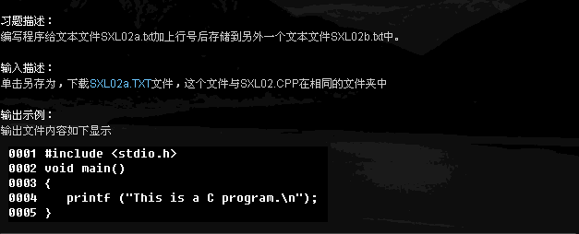
#include<stdio.h>
#include<stdlib.h>
int main()
{
FILE *in,*out;
int i=1;
char ch;
in=fopen("SXL02a.TXT","r");
out=fopen("SXL02b.txt","w");
if(!feof(in)){
fprintf(out,"%04d ",i);
}
while(!feof(in)){
if((ch=fgetc(in))=='\n'){
i++;
fputc('\n',out);
fprintf(out,"%04d ",i);
}
else{
if(ch!=EOF){
fputc(ch,out);
}
}
}
fclose(in);
fclose(out);
return 0;
}

SXL03
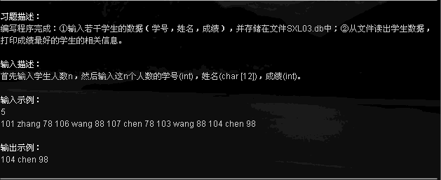
#include<stdio.h>
#include<string.h>
struct stu{
int no;
char name[12];
int score;
}a,b;
int main()
{
FILE *p;
int n,i;
scanf("%d",&n);
p=fopen("SXL03.db","w+");
for(i=0;i<n;i++){
scanf("%d%s%d",&a.no,a.name,&a.score);
fwrite(&a,sizeof(struct stu),1,p);
}
rewind(p);
for(i=0;i<n;i++){
fread(&b,sizeof(struct stu),1,p);
if(a.score<=b.score){
a.no=b.no;
strcpy(a.name,b.name);
a.score=b.score;
}
}
printf("%d %s %d\n",a.no,a.name,a.score);
fclose(p);
return 0;
}

SXL04
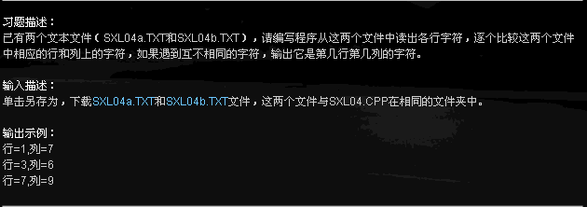
#include<stdio.h>
int main()
{
int i=1,j=1;
FILE *p1,*p2;
char a,b;
p1=fopen("SXL04a.TXT","r");
p2=fopen("SXL04b.TXT","r");
while(!feof(p1) && !feof(p2)){
a=fgetc(p1);
b=fgetc(p2);
if(a=='\n'){
i++,j=1;
}
else{
if(a!=b){
printf("行=%d,列=%d\n",i,j);
}
j++;
}
}
fclose(p1);
fclose(p2);
return 0;
}

IE01
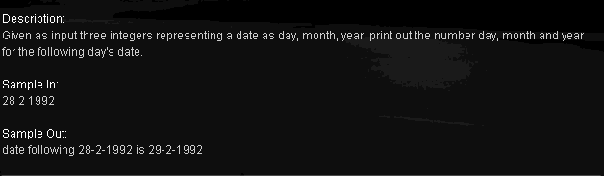
#include<stdio.h>
int main()
{
int i,j,k,flage,n,m,b;
int runnian(int);
scanf("%d%d%d",&n,&m,&b);
i=b,j=m,k=n;
flage=runnian(i);
if(j==12 && k==31){
i++;
j=1;
k=1;
}
else{
if(j==1 || j==3 || j==5 || j==7 || j==8 || j==10 || j==12){
if(k<31){
k++;
}
else{
j++;
k=1;
}
}
else{
if(j==2 && flage){
if(k<29){
k++;
}
else{
k=1;
j++;
}
}
else{
if(j==2 && !flage){
if(k<28){
k++;
}
else{
k=1;
j++;
}
}
else{
if(k<30){
k++;
}
else{
j++;
k=1;
}
}
}
}
}
printf("date following %d-%d-%d is %d-%d-%d\n",n,m,b,k,j,i);
return 0;
}
int runnian(int y)
{
if(y%4==0 && y%100!=0 || y%400==0){
return 1;
}
else{
return 0;
}
}

IE02
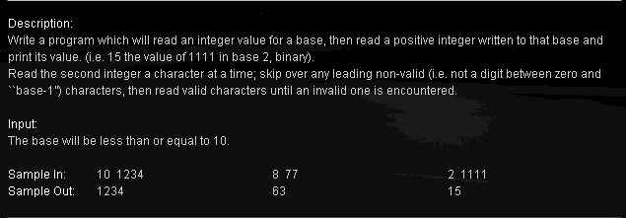
#include<stdio.h>
#include<math.h>
int main()
{
int i,j,k=0,n=0;
scanf("%d%d",&i,&j);
while(j!=0){
k=k+j%10*pow(i,n);
n++;
j=j/10;
}
printf("%d\n",k);
return 0;
}

IE03
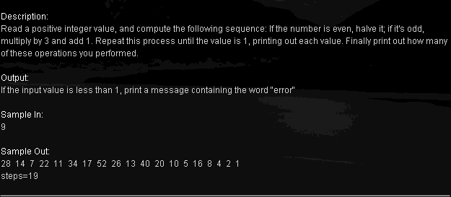
#include<stdio.h>
int main()
{
int i,k=0;
scanf("%d",&i);
if(i<1) printf("error\n");
else{
while(i!=1){
if(i%2){
i=3*i+1;
}
else{
i=i/2;
}
k++;
if(k==1){
printf("%d",i);
}
else{
printf(" %d",i);
}
}
printf("\nsteps=%d\n",k);
}
return 0;
}

IE04
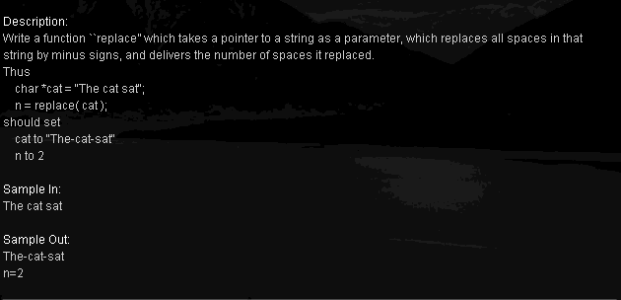
#include<stdio.h>
int main()
{
char a[500];
int n;
int replace(char *);
gets(a);
n=replace(a);
puts(a);
printf("n=%d\n",n);
return 0;
}
int replace(char *p)
{
int n=0;
while(*p!='\0'){
if(*p==' '){
*p='-';
n++;
}
p++;
}
return n;
}

IE05
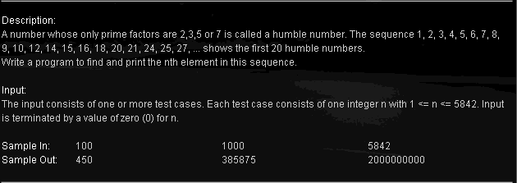
#include<stdio.h>
struct humble
{ long data;
struct humble *next;
}a[5842];
long min(long a,long b,long c,long d)
{
a=a<b?a:b;
a=a<c?a:c;
a=a<d?a:d;
return a;
}
void insert(struct humble *p,struct humble *head)
{
int i=0;
if(head->next==NULL){
head->next=p;
p->next=NULL;
return;
}
while(head->next!=NULL){
if(head->next->data>p->data){
p->next=head->next;
head->next=p;
return;
}
head=head->next;
}
head->next=p;
p->next=NULL;

}
int main()
{
int i,n;
long m;
struct humble *p1,*p2,*p3,*p4,*pm;
a[0].data=1,a[0].next=&a[1];
a[1].data=2,a[1].next=&a[2];
a[2].data=3,a[2].next=&a[3];
a[3].data=5,a[3].next=&a[4];
a[4].data=7,a[4].next=NULL;
p1=p2=p3=p4=&a[1];
for(i=5;i<5842;i++){
m=min(2*p1->data,3*p2->data,5*p3->data,7*p4->data);
if(m==2*p1->data) pm=p1,p1=p1->next;
if(m==3*p2->data) pm=p2,p2=p2->next;
if(m==5*p3->data) pm=p3,p3=p3->next;
if(m==7*p4->data) pm=p4,p4=p4->next;
a[i].data=m;
insert(&a[i],pm);
}
scanf("%d",&n);
pm=&a[0];
for(i=0;i<n-1;i++,pm=pm->next);
printf("%ld\n",pm->data);
return 0;
}

